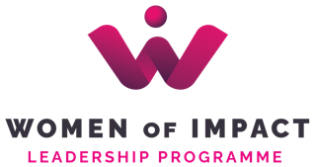

WILP – Women of Impact Leadership Programme
(Programme for Women’s Leadership)

Programme/Modules:

- OFFICIAL START OF THE PRGRAMME & INNER ALIGNMENT – 1 day (24 March 2026) + 1 online session
- Introduction to thought processes
- Emotional intelligence (recognizing and utilizing emotions, controlling fears)
- Being in control of our state of mind
- Self-concept and self-esteem

- INFLUENTIAL COMMUNICATION & NEGOTIATIONS – 2 days (15+16 April 2026)
+ 1 online session
- Advanced listening
- The power of words
- Body language and energy
- Building rapport with interlocutors
- Awareness and intention
- Phases and negotiation strategies
- Planning and preparation for negotiations
- Framing

- PUBLIC SPEAKING & LEADERSHIP AND LEADING OTHERS – 2 days (13+14 May 2026) + 1 online session
- Three key components:
Self-preparation – personal development
Preparation of materials – content, structure, timing
Speaking preparation – body language, voice, movement, dynamics, styles
- Speaking on camera – interviews and statements
- Basics of leadership
- Leadership styles
- Congruent leadership
- Delegating
- Development of others

- PERSONAL PRODUCTIVITY & CERTIFICATION – 1 day (3 June 2026)
- Setting goals and clear results
- Planning and collaborating with time
- Setting priorities and boundaries
- Decision making
- Part of the system

+ One individual mentorship session for every participant.
+ Live, group celebration event upon completion in June 2026
+ Networking with the MK groups.

